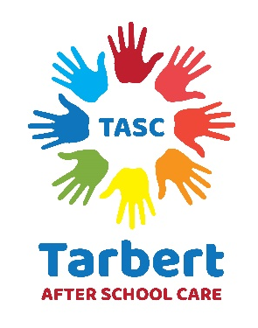
This policy keeps in line with UNCRC Article 31

Every child has the right to relax, play and take part in a wide range of cultural and artistic activities.

Equipment
Tarbert After School Care is committed to providing children with access to a wide range of equipment that stimulates enjoyment, learning and development both indoors and outdoors.
All furniture, toys and equipment are kept clean, well maintained and in good repair accordance with Bs EN safety standards or the Toys (Safety) Regulations (1995) Act where applicable.
Equipment will be properly maintained and inspected in accordance with the manufacturer’s instructions.
Levels of staff supervision will be sufficient to ensure that the safety of children is assured, and set according to the type of equipment being used, along with the ages and number of children involved in a given activity.
The settings equipment and resources reflects positive images with regards to culture, ethnicity, gender and disability.
Resources will, whenever possible, show men and women in a variety of roles and jobs, and people with different abilities being both active and creative. Examples of everyday life will portray people from a variety of family groupings and cultural backgrounds in a range of non-stereotypical roles.
The setting provides a wide selection of books that are regularly updated, as financial resources allow. The selection will always include reference books, and a range of age appropriate formats. Staff are encouraged to select books that reflect a multicultural society, challenge stereotypes, and which meet the educational needs of the children.
Outside the settings opening hours, all equipment will be kept in a suitable and secure location. It is checked daily by staff to ensure that it is safe to play with. When discovered defective or broken equipment will be taken out of use and stored in a safe place before being disposed of. Flammable equipment will be stored in a safe location away from sources of heat and/or naked flames.
The Manager will keep a formal record of any item of equipment loaned to a member of staff, a voluntary organisation or a parent/carer to ensure that it is returned on time and in a good state.
Equipment refers to such things as books and toys while resources could include posters, audio/video equipment, pens and papers.

