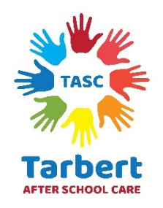
This policy keeps in line with
UNCRC Article 3, 6, 12 & 24;
3 - Adults must do what’s best for me
6 – I should be supported to live and grow
12 – I have the right to be listened to and taken seriously
24 – I have the right to good health care, clean water and good food

Health Eating

Tarbert After School Care aim to raise awareness and encourage a healthier life style in children and young people, to enhance their development and to encourage lifelong eating and life style habits by promoting and providing healthy snacks

Health & Safety is everybody’s business. Tarbert After School Care promotes health & wellbeing by ensuring children and young people within the setting, have access to snacks, including milk and water, which are safe, nutritious, healthy and appealing. The setting provides a role model to enhance children & young people’s knowledge and understanding and to promote positive, healthy attitudes towards diet and life style.

Procedures:
All staff have read and understood this policy
The weekly snack menu will be devised in consultation with children & young
people.
Suitable foods will be offered; this will include children & young people with special
dietary requirements and allergies.
Milk and water will be served with food.
Water will be available at all times.

Parents/Carers of children & young people on special diets will be asked to provide comprehensive written information regarding suitable foods, and in some cases may be asked to provide the food themselves.

A document with children’s names with a special dietary requirement or allergy, will be displayed in the food preparation area, to ensure that staff and volunteers are aware of each individual child’s needs.

Staff will aim to sit with children while they eat, and will act as a good role model for
healthy eating. Withholding food will not be used as a form of punishment within the setting and if a child does not like what is on offer for snack, then they will be provided with something else.

Children & young people will be encouraged to develop good eating skills and table
manners and must remain seated whilst eating.

This policy is written and followed based on the Scottish Government guidance

‘Setting the Table’ hub.careinspectorate.com/media/6013/setting-the-table.pdf

Healthy Eating in Schools Guidance - https://www.gov.scot/publications/healthy-eating-schools-guidance-2020/pages/1/

