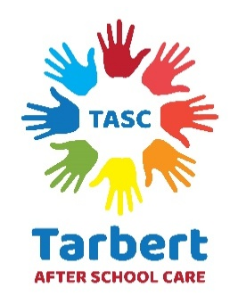
This policy keeps in line with
UNCRC Article 24;

I have the right to good health care, clean water and good food

Infectious and Communicable Diseases

Tarbert After School Care is committed to the health and safety of all children and staff. As such, it will sometimes be necessary to require a poorly child to be collected early from a session or be kept at home while they get better. In such cases, the provisions of the Health protection in children and young people settings, including education policy will be implemented.

In accordance with the procedures set out in the health protection guidance for children and young people settings, including education, parents/carers will be notified immediately if their child has become ill and needs to go home. Poorly children will be comforted, kept safe and under close supervision until they are collected.

If a child has had to go home prematurely due to illness, they should remain at home until they are better or according to the times set out in in the health protection guidance for children and young people settings, including education. If a member of staff becomes ill at work, similar restrictions will apply.

If a child or member of staff becomes ill outside TASC hours, they should notify the setting as soon as possible. The minimum exclusion periods outlined in the health protection in children and young people settings, including education will then come into operation.

If any infectious or communicable disease is detected on the premises, TASC will inform parents/carers personally in writing as soon as possible. The setting is committed to sharing as much information as possible about the source of the disease and the steps being taken to remove it. The care inspectorate will also be informed of any infectious or communicable diseases discovered on the premises.

Head lice
When a case of head lice is discovered at the setting, the situation will be handled carefully and safely. The child concerned will not be isolated from other children, and there is no need for them to be excluded from activities or sessions at TASC.

When the child concerned is collected, their parent/carer will be informed in a sensitive manner.

Other parents/carers will be informed as quickly as possible in writing, including advice and guidance on treating head lice.

Staff should check themselves regularly for lice and treat whenever necessary.

Hand Washing

Children and staff are encouraged to wash their hands before eating, after going to the toilet etc. There will always be hand wash available and drying facilitates.

Guidance

This policy is based on the updated information and guidance set out by Public Health Scotland – Health protection in children and young people settings including education. Please see the links below for full details;

Full up to date guidance - https://publichealthscotland.scot/publications/health-protection-in-children-and-young-people-settings-including-education/health-protection-in-children-and-young-people-settings-including-education-version-1/#section-1

Exclusion periods for illness - https://publichealthscotland.scot/media/25008/2024-04-child-off-school-a4.pdf

Health Protection Team – Highland contact details;

01463 704 886

01463 704 000

Hpt.highland@nhs.scot

