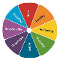
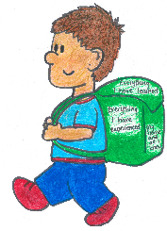

Place photo here
NURTURED

SAFE
ACTIVE
ACHIEVING
RESPONSIBLE
INCLUDED
RESPECTED
HEALTHY
Getting It Right For Every Child

Together we will aim to ensure that you and your family are…


Article 7.

I have the right to a name.

My name is;

________________________________
and this pack is all about me...
welcomes you...
…

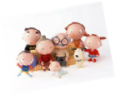
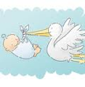



My favourite things to watch on TV are;
_____________________________________________
_____________________________________________

My first language is ___________________

My religion and culture are _____________

___________________________________________________________________________

GIRFEC Wellbeing indicator

I am included.
I live at __________________________________ with my family, who are ____________________________
____________________________________________________________________________________________

I was born on ___________________
Other important people in my life are __________________________________________________________________________________________
GIRFEC Wellbeing indicator

I am nurtured.

Article 9.

I have the right to live with a
family who cares for me.

GIRFEC Wellbeing indicator

I am responsible.
I have a special friend called __________________________________________
I help to care for my pets they are called
___________________________________
_____________________________________________

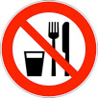
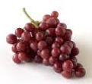
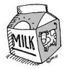
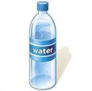


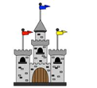
Things that make me happy are

GIRFEC Wellbeing indicator

I am nurtured.
GIRFEC Wellbeing indicator

I am safe.
Foods I know I am not allowed to eat are __________________________________________________________________________________
GIRFEC Wellbeing indicator

I am healthy.

Article 24.

I have the right to clean water
and healthy food.
My favourite foods are ________________________________________________________________________________________
GIRFEC Wellbeing indicator

I am active.
My favourite drinks are
______________________________________________
The things I like to play with/at are __________________________________________________________________________________________
Favourite places I like to go/have been are ________________________________________________________________________________
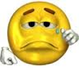
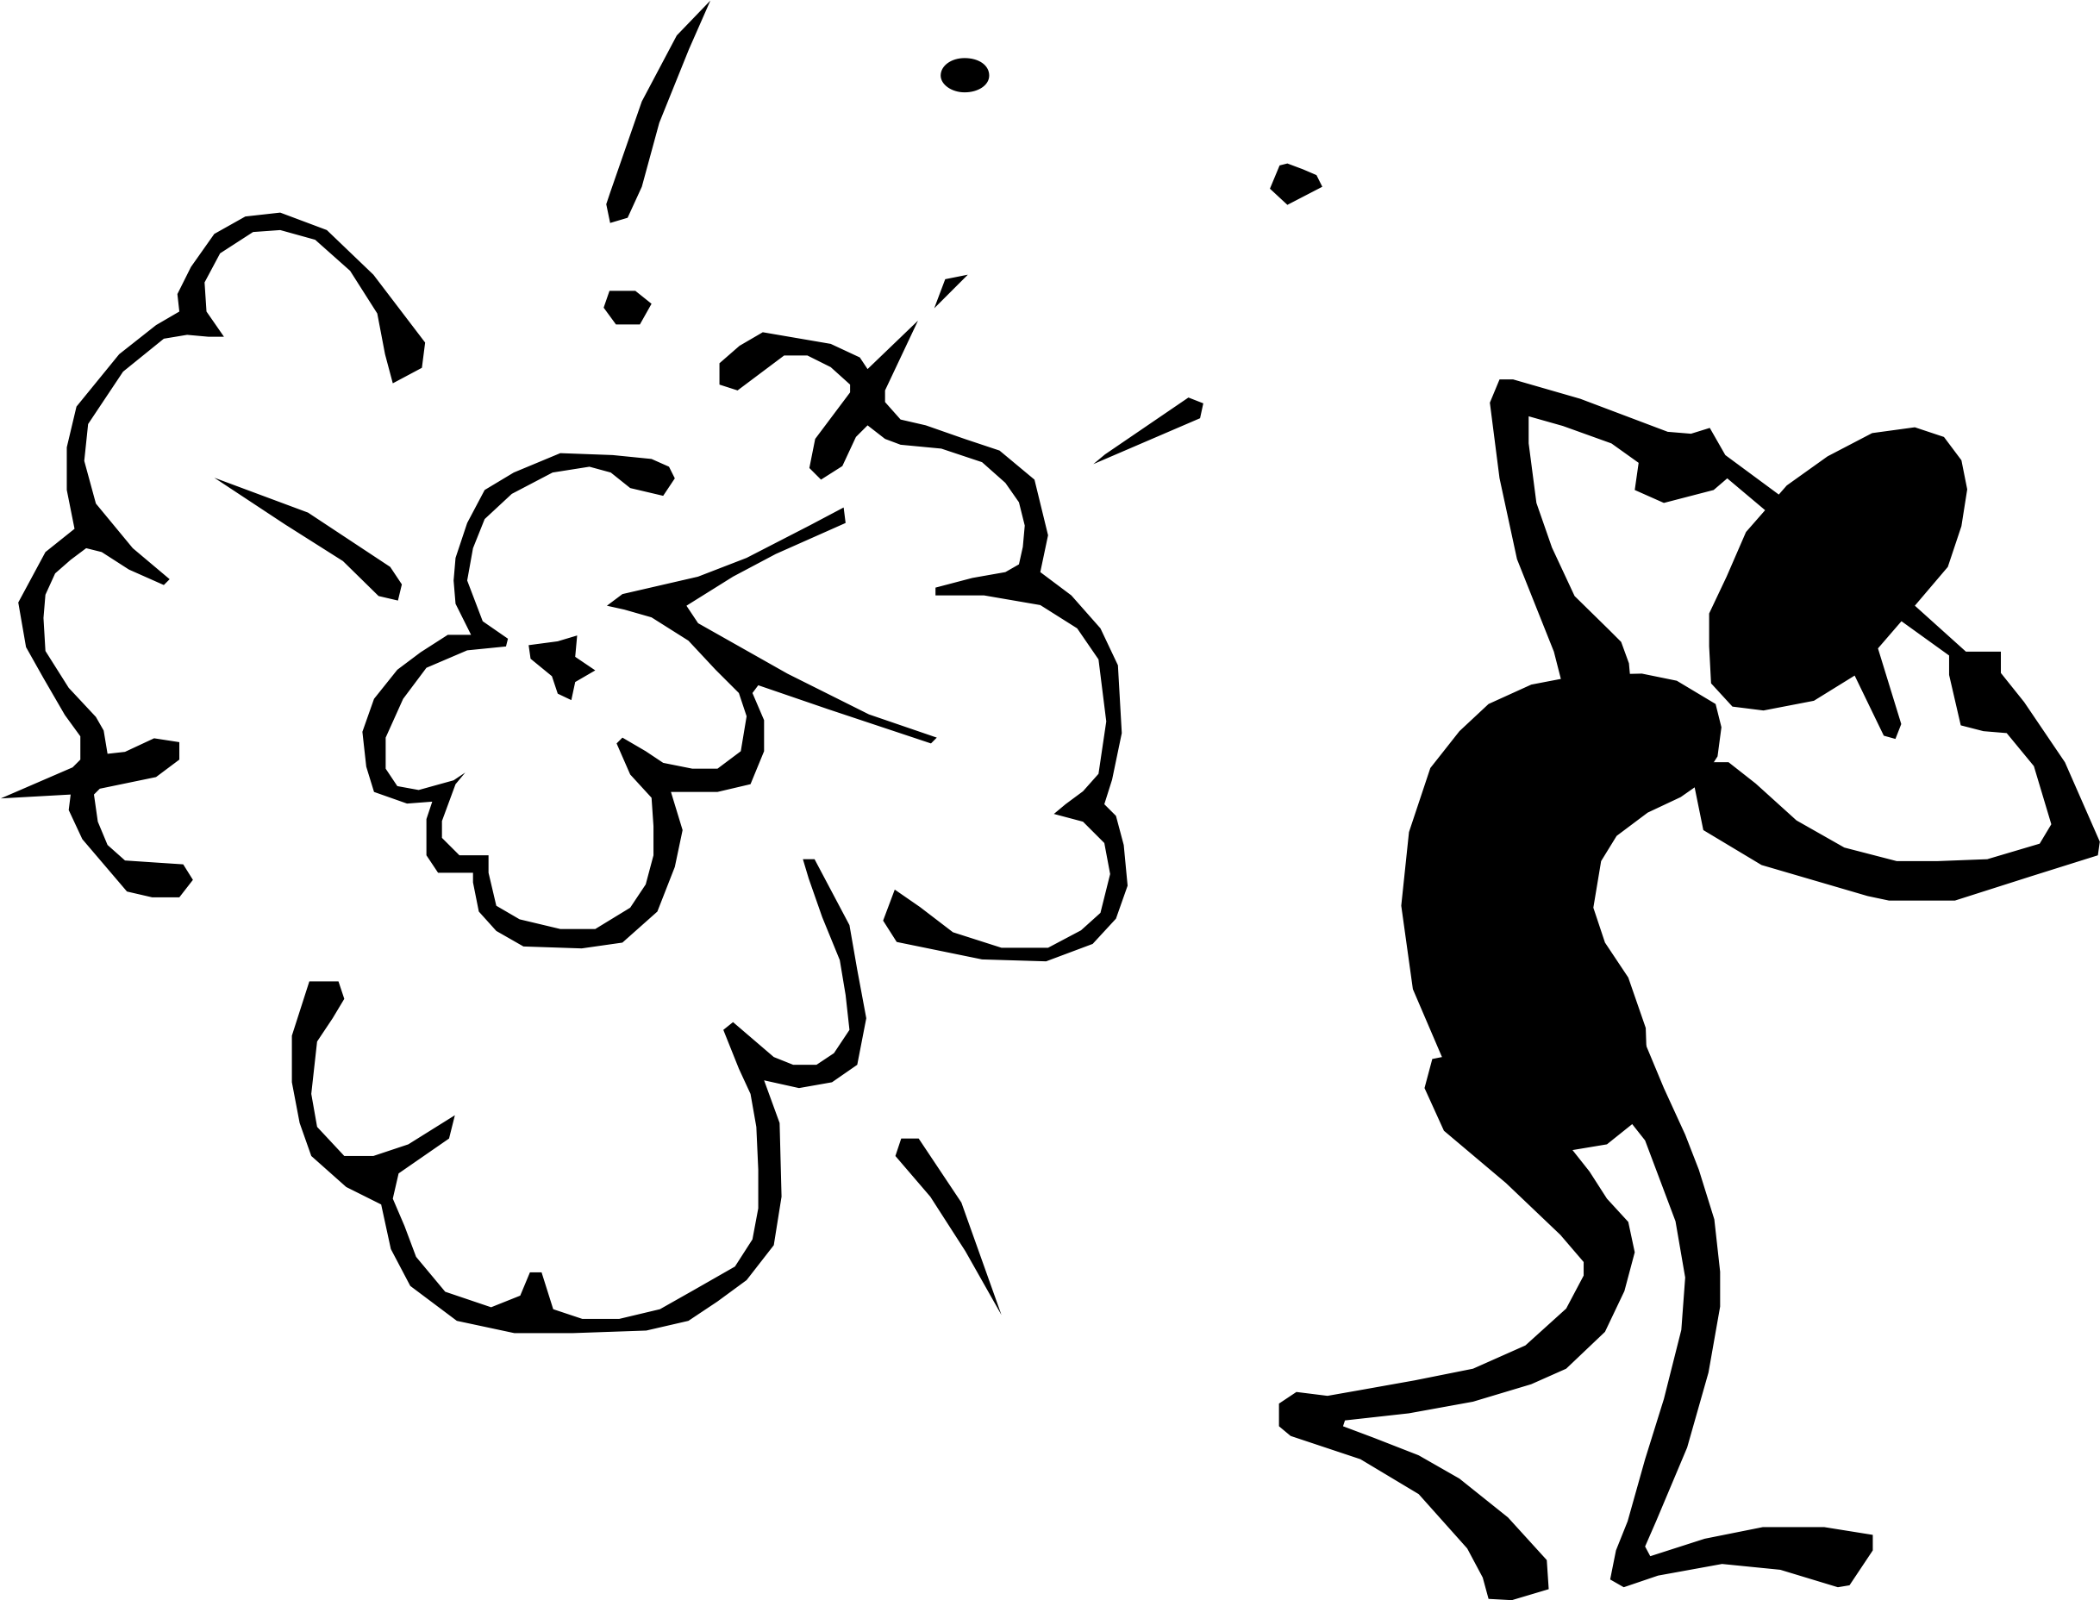
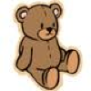
When I am upset I need _________________________________________
Things that make me sad or frightened are

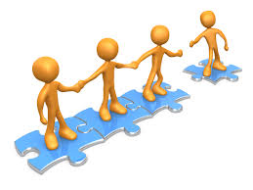

We know that lots of things can make life a bit stressful. Some stresses that people have are:
Things that make me frightened are
____________________________

Periods of transition – new class/school, baby, house
Abuse: physical, sexual or verbal
Neglect: emotional or physical
Drug or alcohol use

I am safe.
Mental health problems
GIRFEC Wellbeing indicator
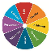
Domestic violence
GIRFEC Wellbeing indicator

I am nurtured.
Family in prison
Parental separation
Struggling to make ends meet

Stress can make it difficult to learn.

If you and your child are experiencing a difficult time due to any of these stresses, we want to support you in order for us to help your child learn.
I have the right to grow up and be healthy.

Article 6
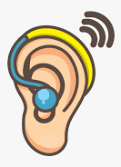
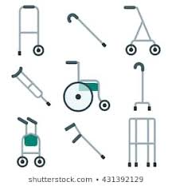

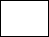
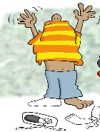
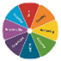
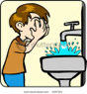
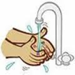
Please provide information on how we can best support your child i.e. communication methods, support with aids/adaptations
Things I need are:

Glasses Hearing aid Mobility aid

We do not expect your child to be able or unable to do any of these. Instead, we are asking just so that we can most appropriately plan their learning.
I can look after myself by:
I need help to...
Not yet
Yes
Put on my own jacket & shoes
Yes
GIRFEC Wellbeing indicator

I am healthy.
GIRFEC Wellbeing indicator

I am responsible.
I use pull ups/nappies

Not yet
I can go by myself
When I need the toilet I say;
___________________________________

Washing my face
Washing my hands
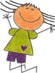
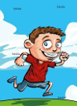
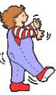
Article 29

I have the right to a good education.

When I am with my family, I am: (Please circle)

Shy Confident Mischievous Curious Friendly
Independent Talkative

Any other information that just makes me, me.
______________________________________________________________________________________________________________________________

My thoughts about starting after school care
____________________________________________________________________________________
Hop
Jump
Run
I can move about on my own…

Article 31.

I have the right to play and rest.

GIRFEC Wellbeing indicator

I am active.
GIRFEC Wellbeing indicator
Not yet
Yes

I am healthy.

I am respected.
GIRFEC Wellbeing indicator

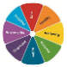
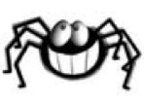
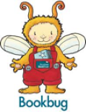
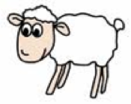
Some of my common words/phrases I use are;
____________________________________________________________________________________________________________________________________________________________________________________________________________________________________
_______________________________________ ______________________________________
GIRFEC Wellbeing indicator

I am respected.

I talk

Yes Not yet When I talk, people understand most
of what I say.

GIRFEC Wellbeing indicator

I am achieving.
GIRFEC Wellbeing indicator

I am included.
Communication
Article 13

With
sounds
With lots of words
With learned phrases
With single words
Not yet
I have the right to share what I think by talking.
When I am speaking, people understand what I am saying
Always
Sometimes
Not really
I am becoming aware of letters, signs and words when I am out and about.
Yes
Not yet
I can sing my favourite song, which is
_________________________________
I enjoy looking at books, my favourite is ________________________________
I can recite my favourite nursery rhyme, which is
____________________________________
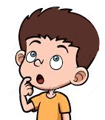
Any other information you think we should know:

Thank you for telling us all this information about what you have been learning at home!
Please bring this booklet back to TASC so that we can use this to help us plan new experiences for you.

Child sign:____________________________________ date:_________
Parent sign:___________________________________ date:_________

(such as special songs, comfort routines, strategies in times of distress).

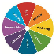
GIRFEC Wellbeing indicator

I am safe.

Don’t forget! I am allergic to:

_________________________

We are so excited to get to know you better, play and learn with you at after school care!
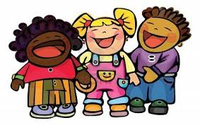
I am respected.
I am
nurtured.

I am included.

